SEO INTRO
Tasks

1.Open Google, Bing, and DuckDuckGo in your browser and search for 'best budget smartphones 2024'. Take screenshots of the first page of results for each search engine and note any differences in the top 3 results.

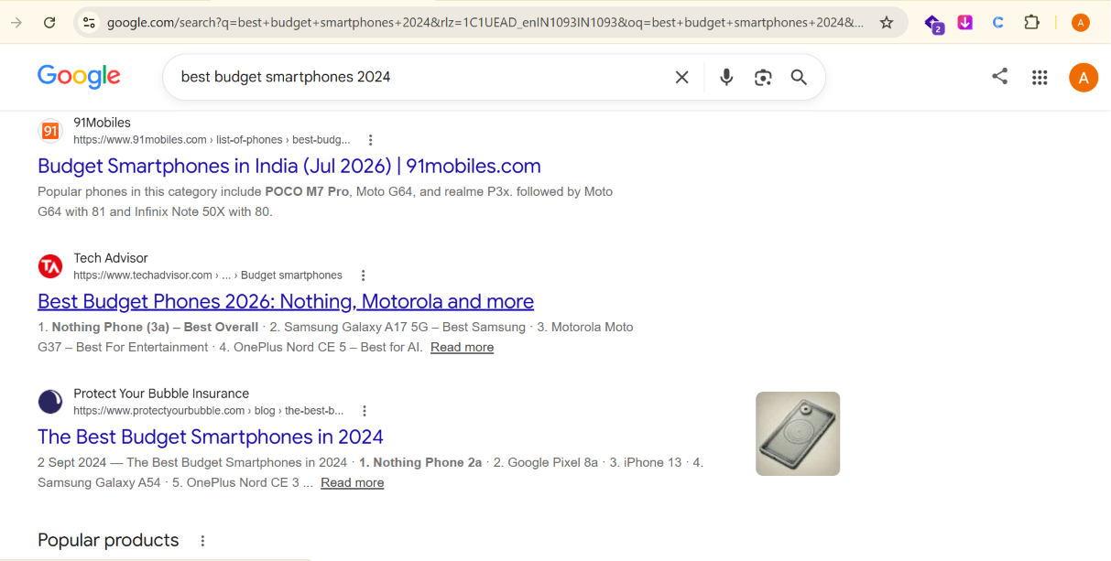
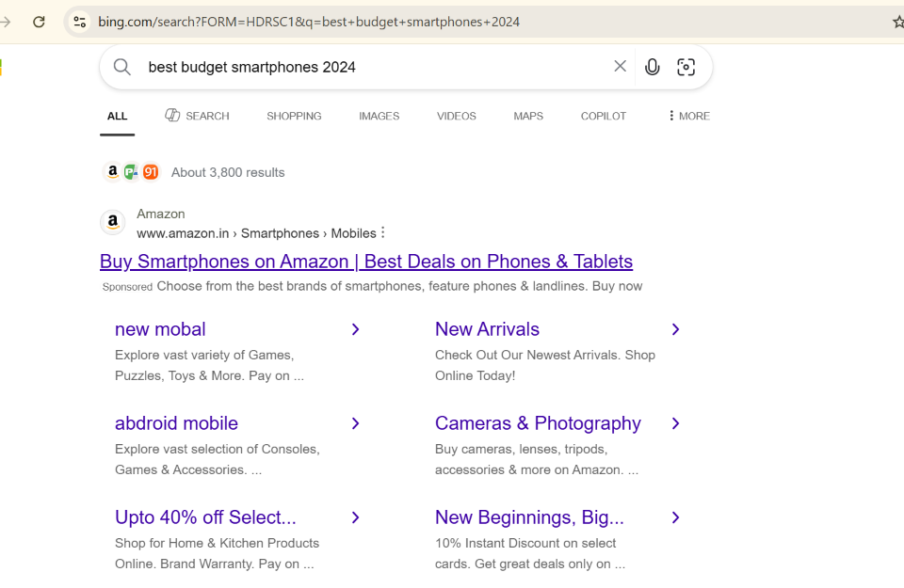
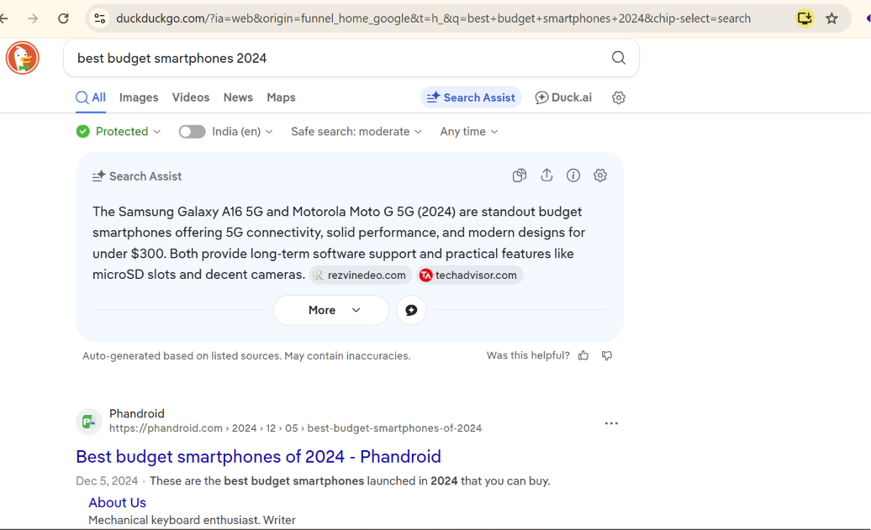

- Observation :
- Google showed more india- specific results.
- Bing displayed more international technology websites.
- DuckDuckGo focused on privacy and showed different ranking results.

2.Create a simple table in a Google Doc or Excel listing 5 popular search engines. For each, write one unique feature or reason why a user might choose it over Google.
Search Engine | Special Featured
Google | The most widely used search engine.
Bing | Microsoft’s search engine.
DuckDuckGo | Focused on user privacy and does not track searches.
Yahoo | Provides search results along with news and other services.
Baidu | The most popular search engine in china.

3.Write a short paragraph (4-5 lines) explaining in your own words the difference between organic results and paid results on a Google search results page. Include an example of each from a recent search you performed.
=> Organic results are the websites that appear naturally on Google based on their quality and relevance. Website owners do not pay Google for these rankings. Paid results are advertisements shown at the top or bottom of the search page. Businesses pay Google to display these ads, and they are usually marked as “Ad” or “Sponsored.”

4.Draw a flowchart (on paper or using any online tool) that shows the 3-stage process Google uses for search: crawling, indexing, and ranking. For each stage, write 1-2 lines describing what happens.

=>
Website -> Crawling -> Indexing -> Ranking -> Search Results
Crawling : Google discovers and scans web pages.
Indexing : Google stores the webpage information in its database.
Ranking : Google ranks the best and most relevant pages for users.

5.Pick any trending topic (like IPL, new movie release, or a gadget launch) and search it on Google. Identify at least 2 organic results and 2 paid results from the first page, then explain how you recognized which was which.<br><br><em><strong>Hint:</strong> Look for labels like 'Ad' or 'Sponsored' and compare their placement on the page.</em>
=>

Organic Results:

1. Cricbuzz – IPL 2026 Fixtures
2. Wikipedia – 2026 Indian Premier League

Paid Results: No sponsored results were displayed for this search.
How I Recognized Them: The results did not have an “Ad” or “Sponsored” label, so they are Organic Results, No Paid Results appeared on the first page.

Comparison:

- Organic Results appear naturally based on Google’s ranking.
- Paid ads were not shown for this search.

